Isaiah Holder

Lab-9

Test Document for Priority Queue

**Operations Input Values Expected Output**

*IsEmpty(): Positive Case* void true

Call IsEmpty before an element

Is inserted.

*Enqueue(int):*

Enqueue 5 values into the queue. 1,2,3,4,5, void

*IsEmpty(): Negetive Case*

Call IsEmpty after five elements

have been inserted. void false

*Dequeue():*

Call Dequeue(), and print the

returned value for each element

in the queue void 5,4,3,2,1

*Enqueue(int):*

Enqueue 5 values into the queue. 1,2,3,4,5, void

*MakeEmpty():*

Call MakeEmpty() void void

*IsEmpty(): Tests the call to MakeEmpty()*

Call IsEmpty void true

Array Implementation:

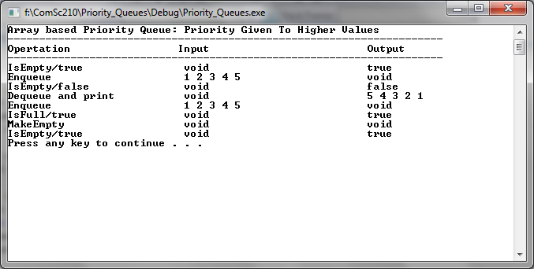

Pointer Implementation:

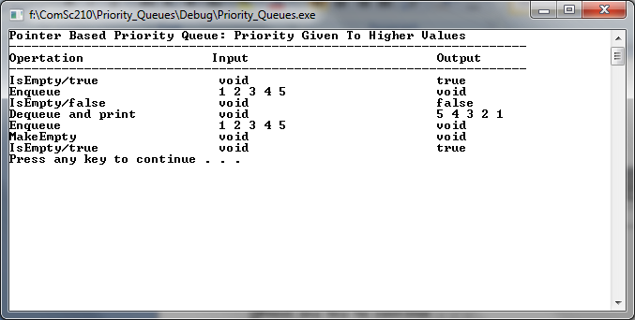

STL Implementation:

